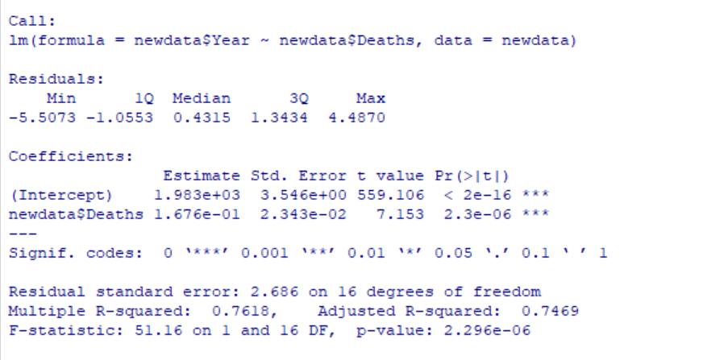

Linear Regression: Using # of deaths to predict what year for Alaska

SSE: 115.42

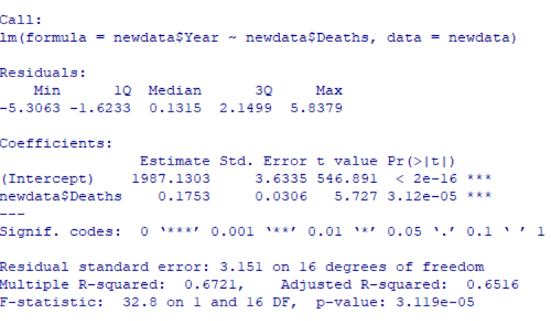

Wyoming

SSE: 158.85

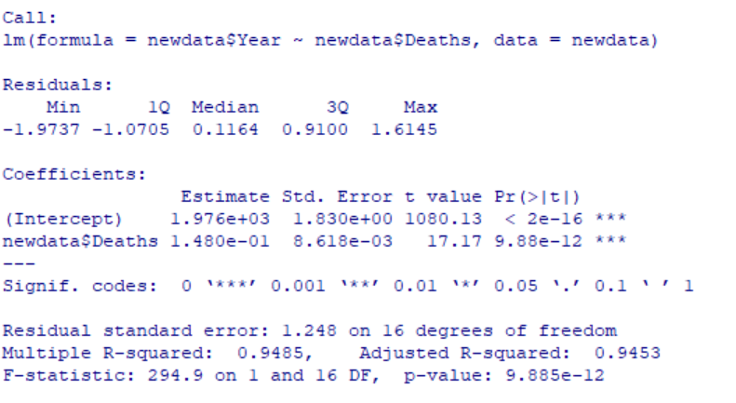

Montana -> r^2 is very high

SSE: 24.93

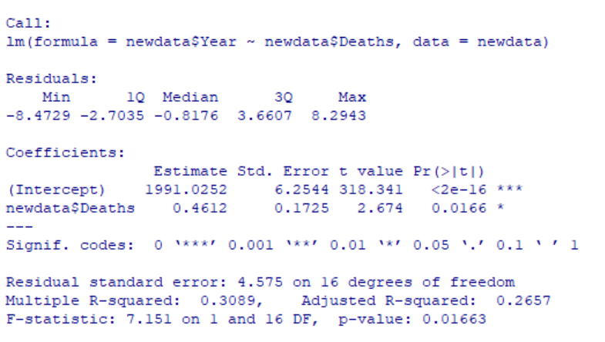

DC

SSE:334.8431

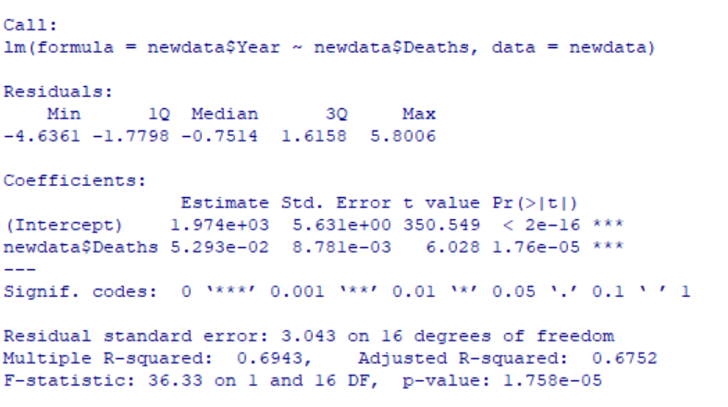

New Jersey

SSE: 148.12

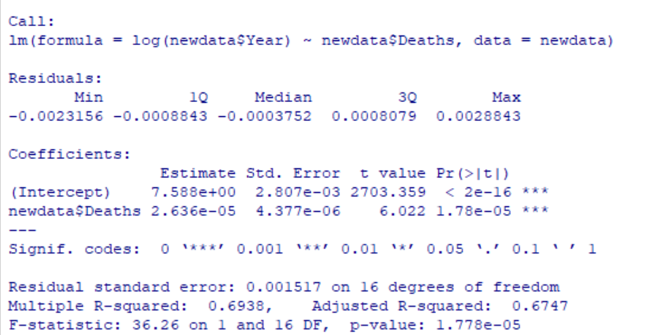

New Jersey exp regression

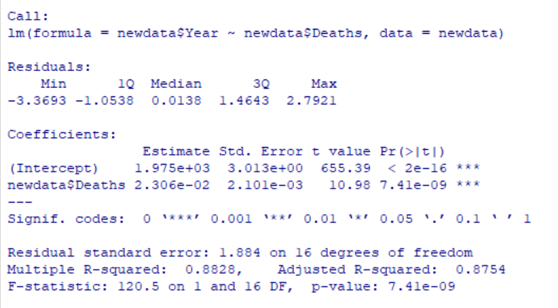

New York

SSE: 56

So can we jump to the conclusion that it’s harder to predict how much suicide there will be in a state with lower suicide rates than higher suicide rates? Or that states with lower suicide rates changed more unpredictably year to year than states with higher suicide rates?

Everything is significant (3 stars), t values are large, and Pr(>|t|), plausibility coefficient of linear regression constant, is 0.

------------------------------------------------------------

W/ relation to “no leisure”

No leisure’s crude prevalence, not age adjusted

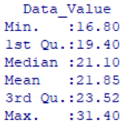

Alaska

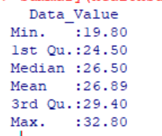

Wyoming

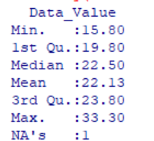

Montana

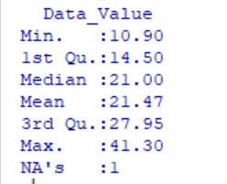

Dc

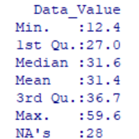

New York

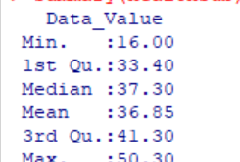

New Jersey

Places that had lesser suicides had… higher percentages of people who had no leisure?

?!?

---> in order to find out for sure… we will have to do clustering analysis, which is way beyond my ability at this point